Script for the first assignment of Filtering and Identification by

Niels Uitterdijk, December '17.

Load data
load('rocket.mat')

Model parameters
dt = 0.1; % [s]
m = 100; % [kg]

1. State space description of simplified rocket dynamics
Both the Continuous as the Discrete model give the same output. Although this is not very accurate when compared to the measured data or the real data, it does coincide with the measured trajectory once.
Ac = [0 1; 0 0];
Bc = [0 0 0; 1/m -1 -1/m];
Cc = [1 0];
Dc = 0;

Descretised model of simplified rocket dynamics
Ad = [1 dt; 0 1];
Bd = [dt^2/2/m, -dt^2/2, -dt^2/(2*m); dt/m, -dt, -dt/m];
Cd = [1 0];
Dd = 0;

Simulate the discrete model
Xd = zeros(2,length(u)); Yd = zeros(1,length(u));
for n=1:length(u)-1
Xd(:,n+1) = Ad*Xd(:,n) + Bd*u(n,:)';
Yd(n+1) = Cc*Xd(:,n+1);
end

Simulate the continuous model
T = linspace(0,(length(u)-1)*dt,length(u));
rocket_con = ss(Ac,Bc,Cc,Dc);
[Yc, Tc, Xc] = lsim(rocket_con,u',T,[]);

Plot outcome
figure
plot(T,Yc,T,Yd,T,ytrue)
legend('Continuous Model','Discrete Model','Data')
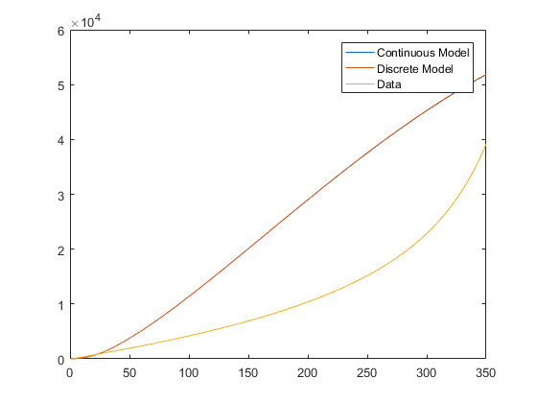

2. Generate Asymptotic Observer
The discrete model was used to generate an Asymptotic Observer. The model has significantly increased in accuracy. Although the variance of the speed estimation is still quite high, the estimation seems unbiased. Also the altitude estimation has increased significantly, with an accuracy of 8m at an altitude of 3000m.
if rank([Cd; Cd*Ad]) == 2
fprintf('The system is Observable\n');
else
fprintf('The system is NOT Observable\n');
end
p = [0.8 0.7];
Kao = place(Ad',Cd',p)';
The system is Observable

Simulate the discrete Asymptotic Observer model
Xao = zeros(2,length(u)); Yao = zeros(1,length(u));
Uao = [u y];
for n=1:length(u)-1
Xao(:,n+1) = [Ad - Kao*Cd]*Xao(:,n) + [Bd Kao]*Uao(n,:)';
Yao(n+1) = Cd*Xao(:,n+1);
end
hold on

Validation of Asymptotic Observer
figure % Check altitude estimation
plot(T,Yao,T,ytrue)
legend('Asymptotic Observer','Data');title('Altitude Estimation')
figure % Check velocity estimation
plot(T,Xao(2,:),T,ydottrue)
legend('Asymptotic Observer','Data');title('Speed Estimation')
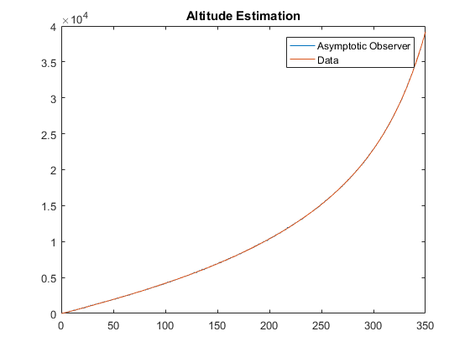
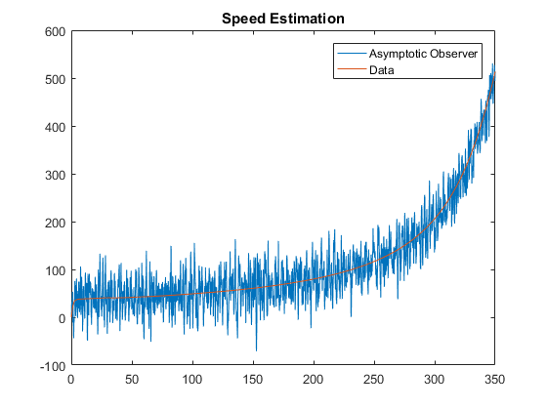

3. Kalman filter
The Kalman filter results in a lot smoother speed estimation. The variance is now significantly lower while keeping the unbiasedness. However, the variance of the estimate of the altitude has slightly decreased. The variance matrix of the model is quite hard to estimate although the consequences of in/de-creasing it is obvious. I would conclude that the Kalman filter yields a better result than the asymptotic observer as the speed estimation is much more reliable now while the altitude estimation only slightly decreases in variance but remains a very decent estimate.
R = 1e3; % Variance matrix W (Model Accuracy)
Q = 0.1*eye(2); % Variance matrix V (Measurement Accuracy)
S = zeros(2,1);
if rank([Q^(1/2) Ad*Q^(1/2)]) == 2
fprintf('The system is Reachable\n')
else
fprintf('The system is NOT Reachable\n')
end
[P,L,Kkf] = dare(Ad',Cd',Q,R);
The system is Reachable

Simulate the discrete Kalman filter model
Xkf = zeros(2,length(u)); Ykf = zeros(1,length(u));
for n=1:length(u)-1
Xkf(:,n+1) = (Ad - Kkf'*Cd)*Xkf(:,n) + Bd*u(n,:)' + Kkf'*y(n) ;
Ykf(n+1) = Cd*Xkf(:,n+1);
end
figure % Plot Kalman Filter Altitude Estimation
plot(T,y,T,Ykf)
legend('Data','Kalman Filter');title('Altitude Estimation')
figure % Plot Kalman Filter Speed Estimation
plot(T,ydottrue,T,Xkf(2,:))
legend('Data','Kalman Filter');title('Speed Estimation')
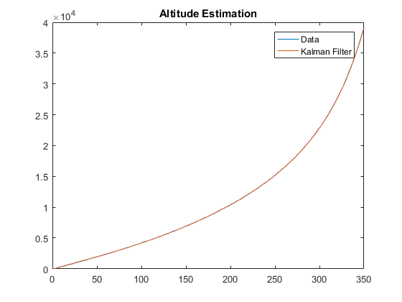
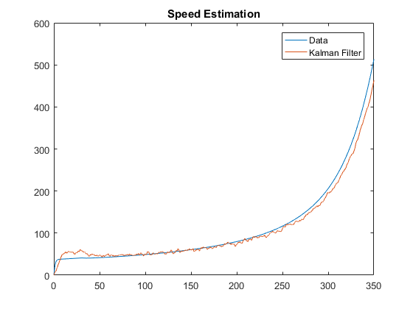

4. Other possible methods
One example that might work is the Moving Horizon Estimation. This should work as well but needs more iterations to converge. There are plenty of other options as well. For example as named in the book a recursive Kalman filter would probably also improve the estimates given here.

5. Design new Drag Model
The rockets altitude estimation remains good. The speed estimation is initially quite off and stays noisier during the entire simulation and therefor has become slightly worse. The drag force is also quite noisy but does follow the actual drag force quite nicely. It is obvious that the variance of the estimation must be quite high to keep a good estimation for the transient behaviour of the non-linear drag force.
size = 3;
Adm = [Ad Bd(1:2,3); 0 0 1];
Bdm = [Bd(1:2,1:2); 0 0];
Cdm = [1 0 0];
Xdm = zeros(size,length(u)); Ydm = zeros(1,length(u));
Udm = [u(:,1:2)];

Design Kalman Filter for augmented state space model
Rdm = R;
Qw = 0.1*eye(size-1);
Qu = 50*eye(1);
Qdm = [Qw zeros(2,1);zeros(1,2) Qu];
[P,L,Kdm] = dare(Adm',Cdm',Qdm,Rdm);

Check requirement for no measurabl input sequence
if rank([Cdm; Cdm*Adm; Cdm*Adm*Adm]) == size
fprintf('The new drag model is Observable\n');
else
fprintf('The new drag model is NOT Observable\n');
end
if rank([Qdm^(1/2) Adm*Qdm^(1/2) Adm*Adm*Qdm^(1/2)] ) == size
fprintf('The new drag model is Reachable\n')
else
fprintf('The new drag model is NOT Reachable\n')
end
The new drag model is Observable
The new drag model is Reachable

Simulate the discrete Kalman filter model
for n=1:length(u)-1
Xdm(:,n+1) = (Adm - Kdm'*Cdm)*Xdm(:,n) + Bdm*Udm(n,:)' + Kdm'*y(n);
Ydm(n+1) = Cdm*Xdm(:,n+1);
end
figure
plot(T,y,T,Ydm)
legend('Data','Kalman Filter');title('Altitude Estimation')
figure
plot(T,ydottrue,T,Xdm(2,:))
legend('Data','Kalman Filter');title('Speed Estimation')
figure
plot(T,Xdm(3,:),T,dtrue)
legend('Estimated Drag Force','Real Drag Force')
title('Drag Model Estimation')
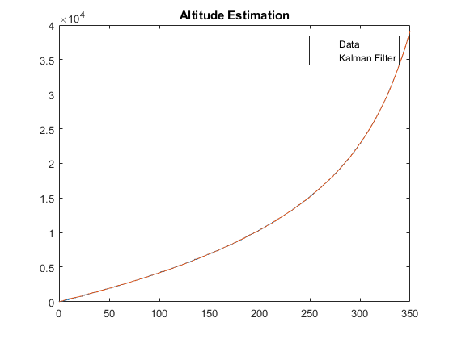
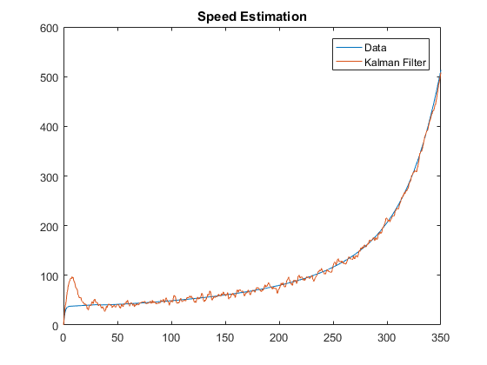
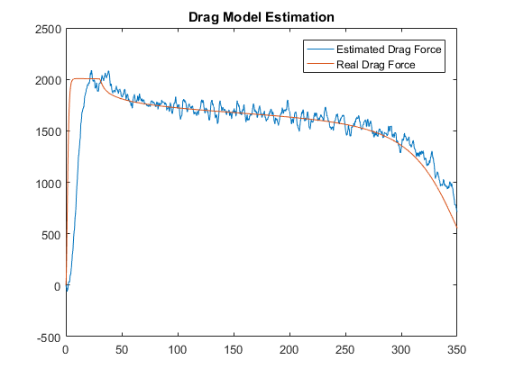

6. Error comparison
If one is interested in the drag force it is obvious that the Kalman filter with input estimation is the best. When solely interested in the altitude estimation I would use the Asymptotic Observer. The Kalman filter does allow to shift the estimations between noisy and unbiasedness which can be very powerful. But only when the unknown input is also simulated the results start to significantly improve.
N = length(ytrue);
E_ao(1) = sqrt(1/N*sum(ytrue - Yao')^2);
E_ao(2) = sqrt(1/N*sum(ydottrue - Xao(2,:)')^2);
E_ao(3) = sqrt(1/N*sum(dtrue - u(:,3))^2);
E_kf(1) = sqrt(1/N*sum(ytrue - Ykf')^2);
E_kf(2) = sqrt(1/N*sum(ydottrue - Xkf(2,:)')^2);
E_kf(3) = sqrt(1/N*sum(dtrue - u(:,3))^2);
E_dm(1) = sqrt(1/N*sum(ytrue - Ydm')^2);
E_dm(2) = sqrt(1/N*sum(ydottrue - Xdm(2,:)')^2);
E_dm(3) = sqrt(1/N*sum(dtrue - Xdm(3,:)')^2);
fprintf('Estimator, RMSE Altitude, RMSE Speed, RMSE Drag\n')
fprintf('Asymptotic, %.3f %.3f %.3f\n',E_ao(1),E_ao(2),E_ao(3))
fprintf('Kalman, %.3f %.3f %.3f\n',E_kf(1),E_kf(2),E_kf(3))
fprintf('Drag model, %.3f %.3f %.3f\n',E_dm(1),E_dm(2),E_dm(3))
Estimator, RMSE Altitude, RMSE Speed, RMSE Drag
Asymptotic, 32.613 51.697 6705.796
Kalman, 619.581 289.738 6705.796
Drag model, 33.778 31.963 977.762
Published with MATLAB® R2016b

